

**FLYING WHALE AIRLINE ANALYSIS**

PRESENTED BY ABDULLAH ZUNORAIN



**CONTENT:**

1. About Dataset
2. Objective
3. KPIs and Key Insights
4. Flight Activity Analysis
5. Customer Loyalty Segmentation Analysis
6. Membership Trends
7. Recommendation and Strategies
8. Conclusion

**ABOUT DATASET**

**1. Customer Flight Activity**

**Loyalty Number:** Customer's unique loyalty number

**Year:** Year of the period

**Month:** Month of the period

**Flights Booked:** Number of flights booked for member only in the period

**Flights with Companions:** Number of flights booked with additional passengers in the period

**Total Flights:** Sum of Flights Booked and Flights with Companions

**Distance:** Flight distance traveled in the period (km)

**Points Accumulated:** Loyalty points accumulated in the period

**Points Redeemed:** Loyalty points redeemed in the period

**Dollar Cost Points Redeemed:** Dollar equivalent for points redeemed in the period in CDN

**2. Customer Loyalty History**

**Loyalty Number:** Customer's unique loyalty number

**Country:** Country of residence

**Province:** Province of residence

**City:** City of residence

**Postal Code:** Postal code of residence

**Gender:** Gender

**Education:** Highest education level (High school or lower > College > Bachelor > Master > Doctor)

**Salary:** Annual income

**Marital Status:** Marital status (Single, Married, Divorced)

**Loyalty Card:** Loyalty card status (Star > Nova > Aurora)

**CLV:** Customer lifetime value - total invoice value for all flights ever booked by member

**Enrollment Type**: Enrollment type (Standard / 2018 Promotion)

**Enrollment Year:** Year Member enrolled in membership program

**Enrollment Month:** Month Member enrolled in membership program

**Cancellation Year:** Year Member cancelled their membership

**Cancellation Month:** Month Member cancelled their membership

**OBJECTIVE:**

Flying Whale Airline embarked on a strategic initiative to enhance its business intelligence capabilities with the aim of optimizing customer experience, understanding travel patterns, and maximizing loyalty program effectiveness. By leveraging data analytics, the airline sought to gain insights into customer behavior, preferences, and expectations to tailor services, anticipate peak travel times, and allocate resources efficiently.

Furthermore, analysis of loyalty program data aimed to identify factors influencing loyalty and customize program benefits to foster stronger customer retention. Through this initiative, Flying Whale Airline aimed to position itself as a leader in the aviation industry by delivering exceptional service, driving customer satisfaction, and ensuring sustainable growth.

**KEY INSIGHTS**

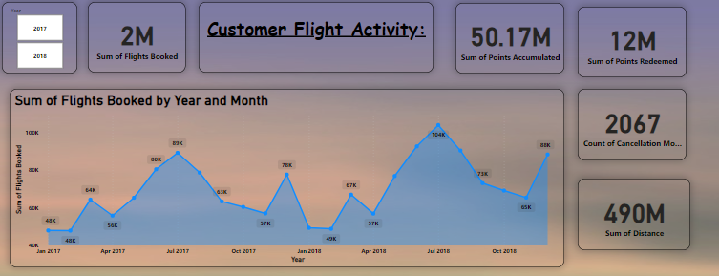

**FLIGHT ACTIVITY ANALYSIS:**

**Seasonal Booking Insights Clear Yearly Rhythm:** Bookings fluctuate with peaks likely driven by spring break, summer vacations (July), and holiday travel (December), with lulls in between.

**Consistent Year-to-Year:** 2017 and 2018 show similar trends, but 2018 has higher peaks, suggesting growth.

**Strategic Implications Maximize Peak Seasons:** Boost capacity and promotions aligned with spring break, summer, and holidays to capitalize on high demand.

**Combat Off-Season Dips:** Introduce incentives to encourage travel during slower periods. Consider the start of the school year as a potential reason for the post-summer dip.

**Forecast & Optimize:** Use this predictability for better capacity management, dynamic pricing, and targeted marketing.

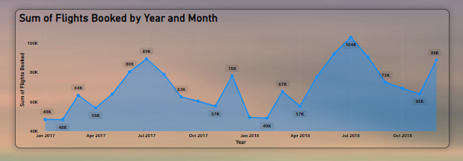

**FLIGHT ACTIVITY ANALYSIS:**

**Flight Distance vs. Loyalty Points Strong Positive**

**Correlation:** Customers earn more loyalty points for longer flights.

**Outliers:** Some very long flights yield exceptionally high points, likely representing frequent or long-haul flyers.

**Potential Points Cap:** The dashed line suggests a maximum accumulation limit, or it could be the highest value in this dataset.

**Business Implications Target Long-Distance Travelers:** Consider incentives to reward these high-value customers further.

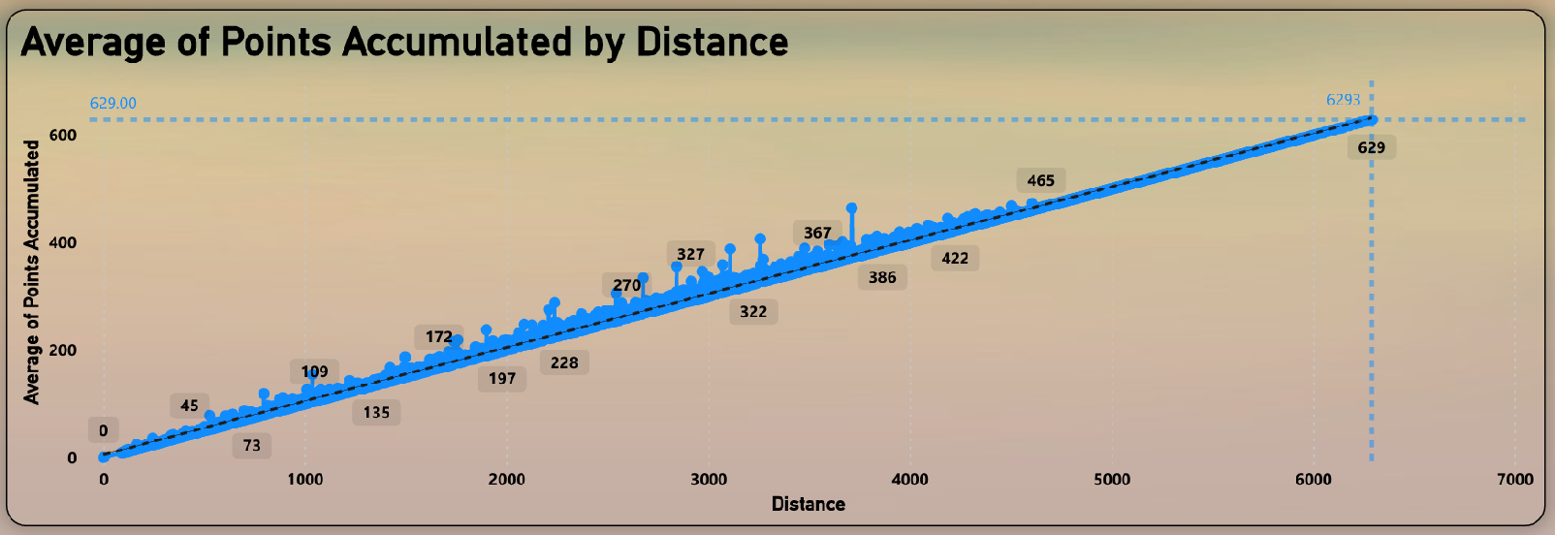

**Points Redeemed vs. Flight Companions Peak with Small Groups:**

Customers redeem the most points with 2 or 3 companions, suggesting strong loyalty engagement within these groups.

**Diminishing Returns:** Points redeemed decrease as group size grows beyond 3. Larger groups are either less likely to redeem or book less frequently. Lowest for Solo & Large Groups Single travelers (0 companions) and very large groups (10 companions) redeem the fewest points.

**Strategic Implications Target 2-3 Companion Groups:** Promotions for this group could have a high return on investment.

**Investigate Larger Group Redemption:** Explore why point redemption drops for larger groups – this may reveal loyalty program improvement opportunities.

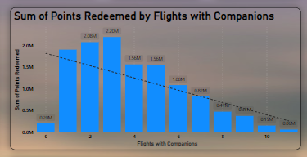

**LOYALTY SEGMENTATION ANALYSIS:**

**Flights by Loyalty Tier Multiple Tiers:** The chart visualizes flight patterns for three loyalty tiers (e.g., Aurora, Nova, Star).

Shared Seasonality: All tiers likely follow similar seasonal trends seen in overall bookings. Tier Volume: Bar heights reveal which tier flies the most. Higher bars suggest frequent flights within a tier.

**Tier Growth:** Track how flight volume changes over time within each tier to gauge program success or engagement shifts.

**Strategic Implications Targeted Loyalty Programs:** Understand what drives flight frequency in each tier to create tailored rewards and incentives.

**Tier-Specific Promotions:** Tailor promotions to boost engagement in less-active tiers or during off peak periods.

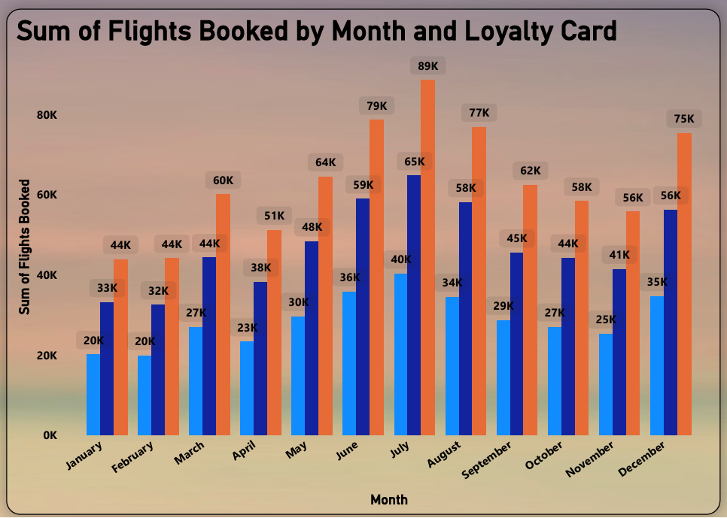

**Membership by Tier Star Dominates:** With 7.64K members (45.6% of the total), Star suggests strong engagement or program longevity.

**Aurora's Strength:** 5.67K members (33.9%) indicates significant participation in this tier.

**Nova's Niche:** The smallest membership at 3.43K (20.5%) suggests Nova might be a premium tier or a recent addition.

**Strategic Implications Understand Star Appeal:** Why is Star so popular? Replicate its success in other tiers.

**Grow Aurora:** Investigate if Aurora's 5.67K member base has reached its potential. Explore growth strategies.

**Define Nova's Role**: If premium, ensure benefits align to attract high-value customers. If new, focus on targeted acquisition.

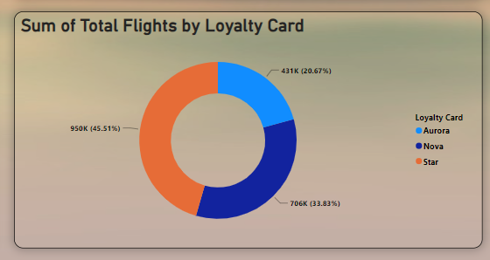

**Marital Status Insights Married Majority:** Over half (58.2%) of members are married, highlighting this group's importance.

**Significant Singles:** Singles represent a sizable segment (26%) of the loyalty program.

**Divorced Minority**: This group comprises the smallest portion of the membership base (15%).

**Strategic Implications Tailor to Married Members:** Offers, rewards, and communications should resonate with this dominant segment.

**Don't Neglect Singles:** Consider promotions or benefits attractive to single travelers.

**Sensitivity for Divorcees:** Messaging and offers should be inclusive without inadvertently ignoring this demographic.

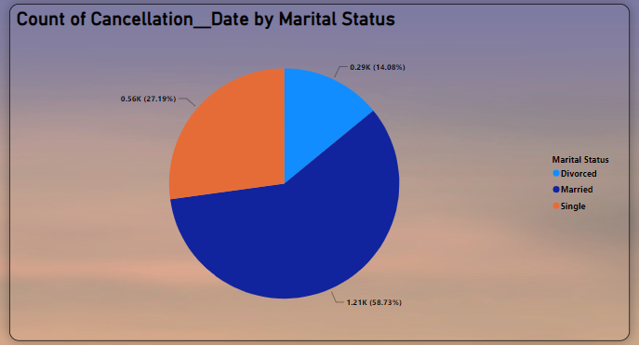

**Tiers Drive Behavior Star Leads:** Star members consistently book the most flights and travel the farthest, regardless of gender.

**Nova Lags:** Nova members have the fewest flights and shortest distances. **Aurora's Value:** Despite fewer flights, Aurora members have the highest CLV Average of $10.8K, suggesting premium spending.

**Strategic Implications Boost Nova Engagement:** Target promotions to increase Nova's flight frequency and distance traveled.

**Maximize Aurora Value**: Focus on retention and upselling for this high-spending tier.

**Tailor by Marital Status: Consider** offers that resonate with the large married segment.

**Gender-Specific Promotions:** Explore if there's value in gender-targeted offers within each tier.

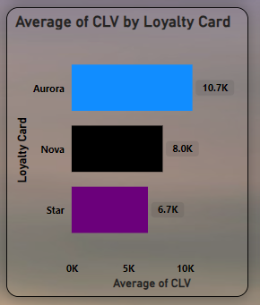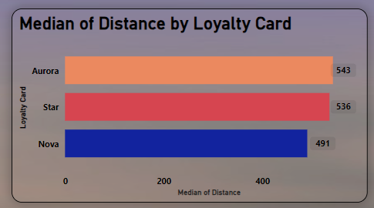

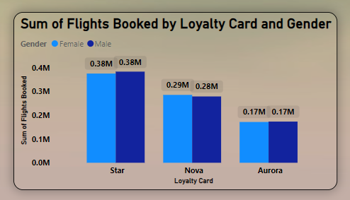

**MEMBERSHIP TRENDS ANALYSIS**

**Insights:**

**Regional Disparity:** Enrollment duration before cancellation varies significantly across provinces. New Brunswick boasts the longest average (19.21 months), while Prince Edward Island has the shortest (12.36 months). Short Duration Focus: Provinces like Prince Edward Island exhibit faster member churn, highlighting a potential issue.

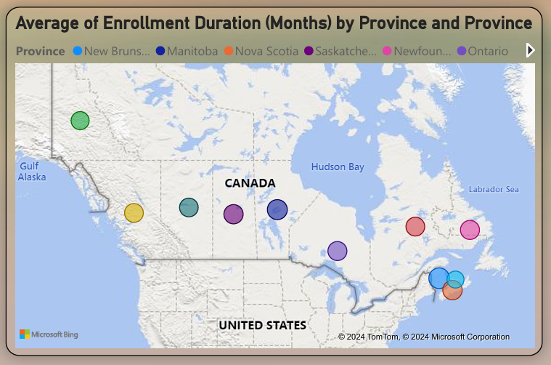

**Implications Loyalty Isn't Uniform:** Customer loyalty differs between provinces. This could be due to regional preferences, the presence of alternative travel options, or the success of localized marketing efforts. Retention Needs Improvement: The short enrollment durations in specific provinces suggest the loyalty program could be better optimized for these regions.

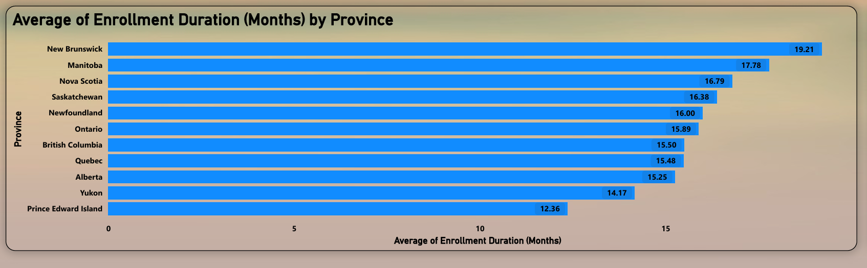

**CANCELLATION INSIGHTS**:

**Monthly Trends Seasonal Pattern:** Loyalty program cancellations exhibit a clear seasonal trend. Cancellations spike significantly in the final quarter (October December), with December having the highest number. Conversely, cancellations are more stable throughout the middle of the year and reach a low point in the early months (e.g., February).

**Strategic Implications End-of-Year Evaluation: The year-end surge in** cancellations suggests members might be re-evaluating their memberships around this time and potentially opting not to renew.

**Benefit Expiration & Holiday Budgeting**: Expiring benefits or annual fees coinciding with the holiday season could prompt financial re-evaluations and membership cuts.

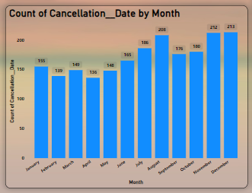

**Demographics & Card Tiers:**

**Education & Cancellation:** Bachelor's degree holders have the highest cancellation rate (62.2%). This could be due to this group being the largest in the program or having unique travel needs that aren't being met.

**Marital Status & Cancellation:** Married members exhibit the highest cancellation rate (58.7%). This might indicate that life changes associated with marriage, such as having children or shifting travel preferences, are influencing loyalty program retention.

**Card Tier & Enrollment Duration:** Aurora cardholders have the shortest average enrollment duration before cancellation. This suggests potential dissatisfaction with the program or a mismatch between the offered benefits and their expectations.

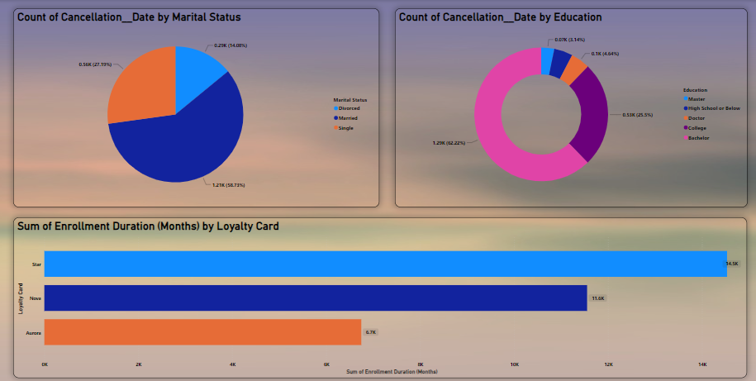

**Narrative Visual (autogenerate insights):**

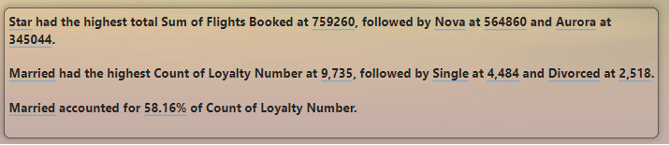

**RECOMMENDATION AND STRATEGIES:**

**Strategic Implications Segment-Specific Needs:** Demographics like education and marital status can influence cancellation rates. Understanding these variations allows for targeted program improvement. Aurora Tier Concerns: The short enrollment duration for Aurora members indicates a need to investigate reasons for their dissatisfaction and potentially improve the tier's rewards or communication.

**Actions Bachelor's Degree Deep Dive:** Conduct research (surveys, focus groups) to understand why Bachelor's degree holders cancel frequently. Tailor program offerings to address their specific travel needs and preferences.

**Improve Aurora Tier:** Investigate reasons behind high cancellation rates in the Aurora tier. Consider enhancing rewards or improving communication to increase loyalty within this segment.

**Tailor to Married Couples:** Explore offering incentives or benefits that resonate with married couples, potentially focusing on family travel or couple-oriented rewards.

**Further Analysis Seek Direct Feedback:** Survey canceling members to understand their reasons for leaving.

**Track Benefits Usage:** Analyze which rewards are popular with different demographics to identify mismatches between what's offered and what members value.

**Monitor Aurora Activity:** Track point redemption and engagement patterns within the Aurora tier to pinpoint areas for improvement and boost loyalty.

**1.Address Seasonality:** Boost capacity & marketing during peak seasons (Spring Break, Summer, Holidays). Introduce off-season incentives to smooth out demand and counter lulls.

**2.Target Loyalty Improvements:** Investigate Aurora tier churn. Adjust benefits to better match expectations. Focus promotions on small groups for higher returns on investment.

**3.Tailor by Demographics**: Craft rewards & communication for Bachelor's & Married segments, the largest groups. Deep dive into why Bachelor's degree holders cancel frequently.

**4.Geographic Strategy:** Strengthen Ontario's presence with targeted offers and route expansions. Explore growth potential in the East and North with new routes or region-specific perks.

**5.Data-Driven Decisions:** Use predictive modeling to forecast point liability and target campaigns. Benchmark your cancellation rates and CLV against industry standards.

**6.Prioritize Feedback & Analysis:** Survey members, especially those who cancel, to better understand their choices. Track reward usage and engagement by demographics to tailor your program effectively.

**CONCLUSION:**

By understanding seasonal travel trends, demographic preferences, and regional variations, Flying Whale Airline has the power to significantly improve its loyalty program. Targeted strategies, informed by data-driven insights, will create a more personalized travel experience, boosting customer satisfaction and strengthening long-term loyalty.